**Pymaceuticals Observations**

1. In preliminary observations of the tumor data, we can start to see a significant difference in Capomulin’s ability to decrease tumor volume as compared to the two other drugs and the placebo. This is promising for Capomulin in at least it’s ability to reduce tumor size.

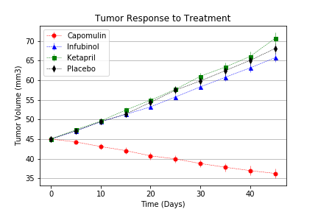

Though the decrease in size is only 19% over the 45 days, that is much more promising than the 46 to 57% increase from the other options captured in this sample. (Analyst’s note: It would be interesting to see all test data for the drug Ramicane, as it decreased tumor volume by over 22%; leading to the question, “Would Ramicane outperform Capomulin in more areas?”

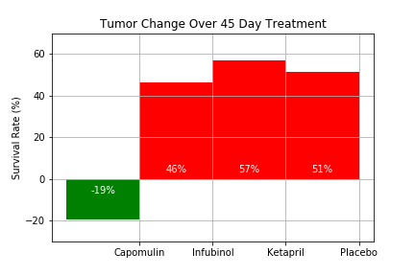

1. With this in mind, we should see review the test groups’ ability to reduce the metastatic spread during the treatment period. Again we see the strongest results coming from Capomulin. And in both measures find that Ketapril is of little help to a simple placebo; bringing to question its efficacy. Though, we must note that our information is specific to treating squamous cell carcinoma; and, perhaps, Ketapril was engineered for a different type of skin cancer.

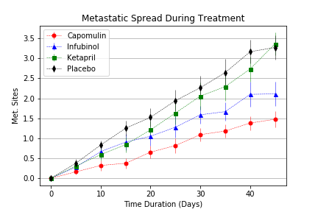

1. In this analyst’s view, the most significant reporting comes from the survival rates of the four treatments observed. At the end of the 45 day trial the roughly 83% survival rate of the Capomulin population is significant compared to Ketapril and Infubinol. Infubinol actually resulting in a lower survival rate than a placebo.

In this simple observation this analyst would recommend further tests of Capomulin to prove it’s efficacy for treating squamous cell carcinoma. And also recommend running analytics on Ramicane to see how it performs in these same areas of focus.

